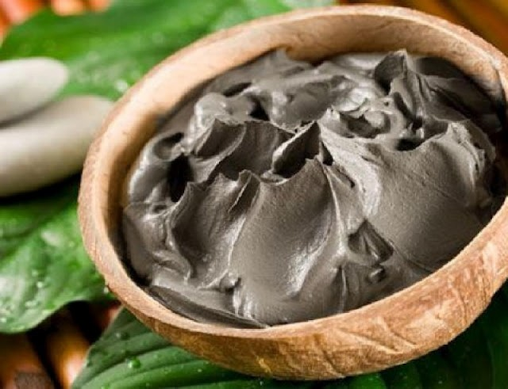
Benefits of LL Magnatic Clay Baths
— The baths are an untreated, unaltered product, used for thousands of years utilizing the Earth's natural healing properties
— The baths safe and effective as an aid to detoxification when used according to the bath instructions. One bath releases years of toxic environmental pollutants that have been accumulating--out of your body and into the bathtub
— The baths are inexpensive and do not require costly equipment. They can save you hundreds of dollars and lots of time compared to chelation therapy and other forms of environmental detoxification programs
— The baths can be taken in the privacy of your own home, with minimal inconvenience
— Healing properties can be maximized if used in combination with other cleansing and maintenance programs
— Formulas of all natural spices and herbs have been synergistically tested as well as specific testing for amounts to maximize the effectiveness of each formula
— Has been tested to show that metals and chemicals are removed through the use of these special formulas
— The baths can be used by children and the elderly
— The clay and formula ingredients are all natural
— Test results have shown that the clay detox bath detoxifies metals from the body much faster than other types of chelation
— Our clay formulas have no emulsifiers or chemical additives to them for easier mixing
— We have found no other clay that has as much natural “pulling power” as LL’s Magnetic Clay
— Our clay detox baths specialize in detoxing metals and chemicals
— Has very small amounts of aluminum compared to most bentonites with 67% to 75%.

